**Lesson 15: Assessment**

**For each of the following questions, please solve or circle your answer from the given choices. Below the question, please show all the steps you used to find the answer. Then, explain why your answer is correct or why the other answers are wrong.**

**Problem One:**

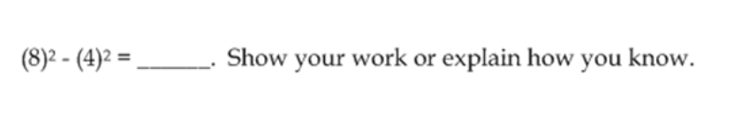

**Steps to get your answer:**

**Justify/explain why your answer is correct or makes sense:**

**Problem Two:**

1. Calculate (-4)2 and -42.
2. Will (-4)9000 be a positive or negative number? Will -49001 be positive or negative?

**Steps to get your answer:**

**Justify/explain why your answer is correct or makes sense:**

**Problem Three:**

$\sqrt{52}$ is a number that is between which two numbers? BONUS: Give as close as approximation as possible.

**Steps to get your answer:**

**Justify/explain why your answer is correct or makes sense:**

**Problem Four:**

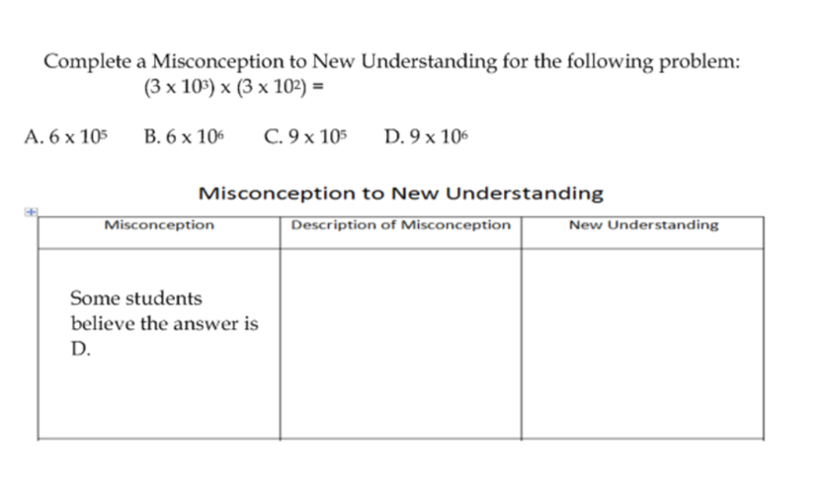

**Steps to get your answer:**

**Justify/explain why your answer is correct or makes sense:**

**Problem Five:**

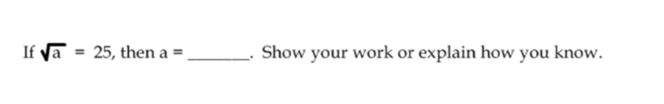

**Steps to get your answer:**

**Justify/explain why your answer is correct or makes sense:**

**Problem Six:**

$$\frac{9×{10}^{9}}{18×{10}^{12}}$$

**Steps to get your answer:**

**Justify/explain why your answer is correct or makes sense:**

**Problem Seven:**

Create your own line graph that details some aspect about yourself (e.g. height, weight, hair length, shoe size). Make up some data, or use as much as you know about yourself to create the graph.